Alaska Indoor Gardening Curriculum

Setting Up the Floating Platform Hydroponic System
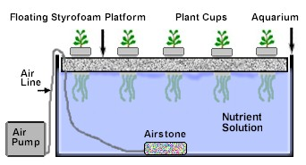
Author/Source: Mel Sikes, Alaska Ag in the Classroom

Suggested Grade Levels: All ages

Time: 45 minutes - 1 hour, follow up monitoring time

Teaching Goal:
To introduce students to the fun of raising edible plants indoors using a floating platform hydroponic growing system.

Learning Objectives:
To explore the plant life cycle by building and operating a floating platform hydroponic growing system.

Core Topics:
- Hydroponic Systems
- Plant Dynamics (circulation and nutrient uptake)
- Plant Life Cycle
- pH, Acidity, and Alkalinity Testing
- Recording Scientific Data in Tables
- Standardized Science Measurements
- Medium Scale construction of a Hydroponic System
- Drawing Conclusions from Experimentation (hands-on, observation, and note-taking)

Standards: Science: 4-LS1-1, 4-PS3-4, 5-PS3-1, 5-LS1-1, 5-LS2-1, MS-LS2-1, MS-LS2-4, MS-LS2-5, MS-ESS3-3, MS-ETS1-4, HS-LS1-2, HS-LS2-5, HS-ESS3-4

NGSS Standards: 4-LS1-1, 5-PS3-1, 5-LS1-1, 3-5-ETS1-1, MS-LS1-5, MS-LS2-1, MS-ESS3-3, MS-ETS1-4, HS-LS1-3, HS-LS2-7, HS-ESS2-6, HS-ESS2-7, HS-ESS3-4, HS-ETS1-3

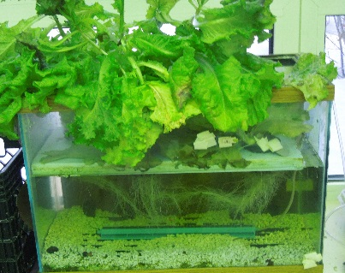
Materials Needed:
- Rockwool, clay grow medium, or other non-soluble medium
- 10, 25 gallon aquarium(s) or sturdy plastic totes
- Styrofoam sheet (1.5 inches thick to house growing bed cups)
- Drill and hole saw bit
- 10 Clear plastic cups (6-12 oz or bigger) or hydroponic net pots
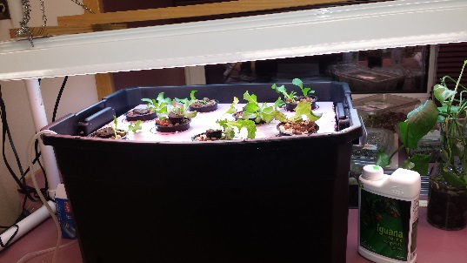
- Knife or pins for root and cup holes
- Pencils
- Popsicle sticks
- Sharpies
- Grow light and stand; T-5 or LED Lights suggested
- Water
- Spray bottles
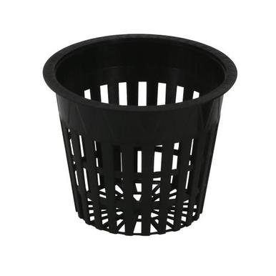
- Hydroponic nutrient mix (liquid or dry)
- Aquarium rocks
- Plant seed (lettuce or herbs but possibly peas too)
- Fish tank air stone and pump system
- Dark paper (to block out 3 sides of aquarium if using aquarium to prevent algae.)

Vocabulary:
- Hydroponics: is a method of growing plants in water without soil. The water must be enriched with nutrients and the plants need some type of inert medium to support the root system.

- Medium: substance or material in which something exists or grows, from the soils and other materials for plant growth.

- pH: stands for power of hydrogen, which is a measurement of the hydrogen ion concentration in the plants. Plants grow best in a slightly acidic pH range of 6 to 7.

- Acidity: the level of acid in substances such as water or soil

- Alkalinity: the ability of water to neutralize acid or to absorb hydrogen ions.

- Algae: algae is an informal term for a large diverse group of photosynthetic organisms which are not necessarily closely related

- Roots: are a very important part of the plant. A root’s four major functions are: absorption of water and inorganic nutrients, anchoring the plant, storage of food and nutrients, and vegetative reproduction.

- Oxygen: plants take in oxygen and give off carbon dioxide nutrients

- Nutrients: plants must obtain the following mineral nutrients for their growing medium they need nitrogen, phosphorus, potassium, calcium, sulfur, and magnesium

Background for Teachers:
Hydroponics is a word based on the combination of two Greek words: Hydro, which means “water” and “ponos” which means work. If you combine them, it means “making water work for you.”

Floating Platform hydroponics is also known as deep water culture hydroponics. This hydroponic method of plant production is done by means of suspending the plant roots in a solution of nutrient-rich, oxygenated water. Traditional methods favor the use of plastic buckets and large containers with the plant contained in a net pot suspended from the center of the lid and the roots suspended in the nutrient solution. The solution is oxygen saturated by an air pump combined with porous stones. With this method, the plants grow much faster because of the high amount of oxygen that the roots receive. - Wikipedia

Hydroponics History (Wikipedia):
The earliest published work on growing terrestrial plants without soil was the 1627 book Sylva Sylvarum or A Natural History by Francis Bacon, printed a year after his death. Water culture became a popular research technique after that. In 1699, John Woodward published his water culture experiments with spearmint. He found that plants in less-pure water sources grew better than plants in distilled water. By 1842, a list of nine elements believed to be essential for plant growth had been compiled, and the discoveries of German botanists Julius von Sachs and Wilhelm Knop, in the years 1859–1875, resulted in the development of the technique of soilless cultivation. Growth of terrestrial plants without soil in mineral nutrient solutions was called solution culture. It quickly became a standard research and teaching technique and is still widely used. Solution culture is now considered a type of hydroponics where there is no inert medium.

In 1929, William Frederick Gericke of the University of California at Berkeley began publicly promoting that solution culture be used for agricultural crop production. He first termed it aquaculture but later found that aquaculture was already applied to culture of aquatic organisms. Gericke created a sensation by growing tomato vines twenty-five feet (7.6 meters) high in his back yard in mineral nutrient solutions rather than soil. He introduced the term hydroponics; water culture, in 1937, proposed to him by W. A. Setchell, a phycologist with an extensive education in the classics.

Procedure:
- Start class off by showing the students a diagram of the system they will be setting up. Show pictures.

- Then tell them step by step instructions on how we will assemble the system together.

- Organize students into groups of 2-3 and assign these duties to groups: mixing growing medium, putting mixed medium into cups, putting holes in cups for roots (if using plastic cups), putting holes in the Styrofoam, rinsing the gravel, setting up the aquarium and adding water to it.

- Cut the Styrofoam float to fit the opening of the tank or tote. Cut the float a little smaller than the opening so that it won't bind up when the water level changes.

- Measure the cups opening diameter first by placing opening side down on the Styrofoam, trace with the sharpie. Draw another circle slightly smaller on the inside of the traced circle with the sharpie.

- Cut the holes in the float to the proper size for the plastic cups or plant pots that you are using. Note: you want the bottoms of the cups to hang below the bottom of the float but not fall through. If you are using plastic cups: cut several holes (approx. 1/8" to 1/4" dia.) in the bottom of your plastic cups.

- Add growing medium to the cup or plant pot. Note: If the growing medium falls out through the holes, you can put a small piece of non-metal window screen or small piece of cloth over the holes before adding the growing medium.

- Assign groups to planting pots and have those groups plant seeds in the medium. Have them write what the plant is on a popsicle stick and insert it into the medium away from the planted seed on the side of the cup. Names can be written on them as well if there is space. You should be able to do 4-6 cups depending on size of aquarium/tote and cups. They can range in size from 6-12 oz.

- Add pre-washed and rinsed aquarium stones to the bottom of the aquarium or tote.

- Attach free end of tubing to air pump and plug in air pump to outlet, make sure that there are bubbles coming from the airstone. Set the airstone in the bottom of the aquarium or tote, sitting on top of the aquarium rocks. Note: NEVER submerge the air pump in water as electrical shock could occur.

- Fill the aquarium or tote with measured room temperature water to 3-4 inches below the rim of the container.

- Add nutrient mixture to water in the aquarium or tote. Read directions on the nutrient container for exact amounts to add based on the gallons of the tank. Stir it gently and give the nutrient time to mix with the water. Check pH and adjust accordingly. Note: The required pH value will vary depending on the requirements of the plant.

- Place the floating platform on top of the water. Plug in and turn on the airstone pump.

- If there is time left, have students tape on dark construction paper to the back, left, and right sides of the aquarium if an aquarium is being used. Once everything is completed, plug in the airstone and turn on the grow light.

- Weekly/daily maintenance will be required including adding water and nutrients, pH monitoring, flushing out accumulated nutrients, etc. See below.

Maintenance and Feeding Instructions
- Have student groups keep track of where they inserted their cup and have them pick a person to water the cups a couple times a week until the roots reach the water/nutrient mixture. Use spray bottle for this. Have the students measure the roots and the plants as they grow.

- When the plants have used up about half of the nutrient solution you can add WATER ONLY to bring the level back up (do not add fertilizer or you could cause a nutrient build up that could harm the plants). Recheck pH and adjust if necessary.

- When the plants have used half of the nutrient solution for the second time you need to change out the nutrient solution by draining the reservoir and then mix a fresh batch. Use the old nutrient solution on house plants or other vegetation.

Extensions: Hydroponic Mediums Lesson, Plant Processes Lesson, Hydroponic Plant Growth Lesson. Monitor plant height growth and root growth.
Consider having students use their science journals to write about this process and to monitor their plants. You can also have students write their predictions, read books about plants, etc.

Assessment: After creating the system, review and summarize the following concepts:
- We can grow food without soil.
- The system must have nutrients to grow healthy plants.
- It is important to monitor the system to keep the plants healthy and growing properly.

Books:
Gardening Indoors with Soil and Hydroponics
by George Van Patten 2007 ISBN: 978-1-878823-32-8

How to Hydroponics by Kenneth Roberto
ISBN: 0-9672026-1-2 2014

Hydroponic Basics: The Basics of Soilless Gardening Indoors
by George F. Van Patton 2004 ISBN: 978-1-878823-25-0

Hydroponics: A Complete DIY Guide for Gardening Using Simple Steps
by Allen Dunn 2012 ISBN: 9781480236141

Websites:
Chena Hot Springs Resort: https://chenahotsprings.com/vertical-bucket-grow-tower/

Foothill Hydroponics: http://www.foothillhydroponics.com/

General Hydroponics: http://generalhydroponics.com/

Hydroponics: https://hydroponics.com/

Institute of Simplified Hydroponics: http://carbon.org/

Simply Hydroponics and Organics: http://www.simplyhydro.com/system.htm

Uponics: http://uponics.com/hydroponic-tower/

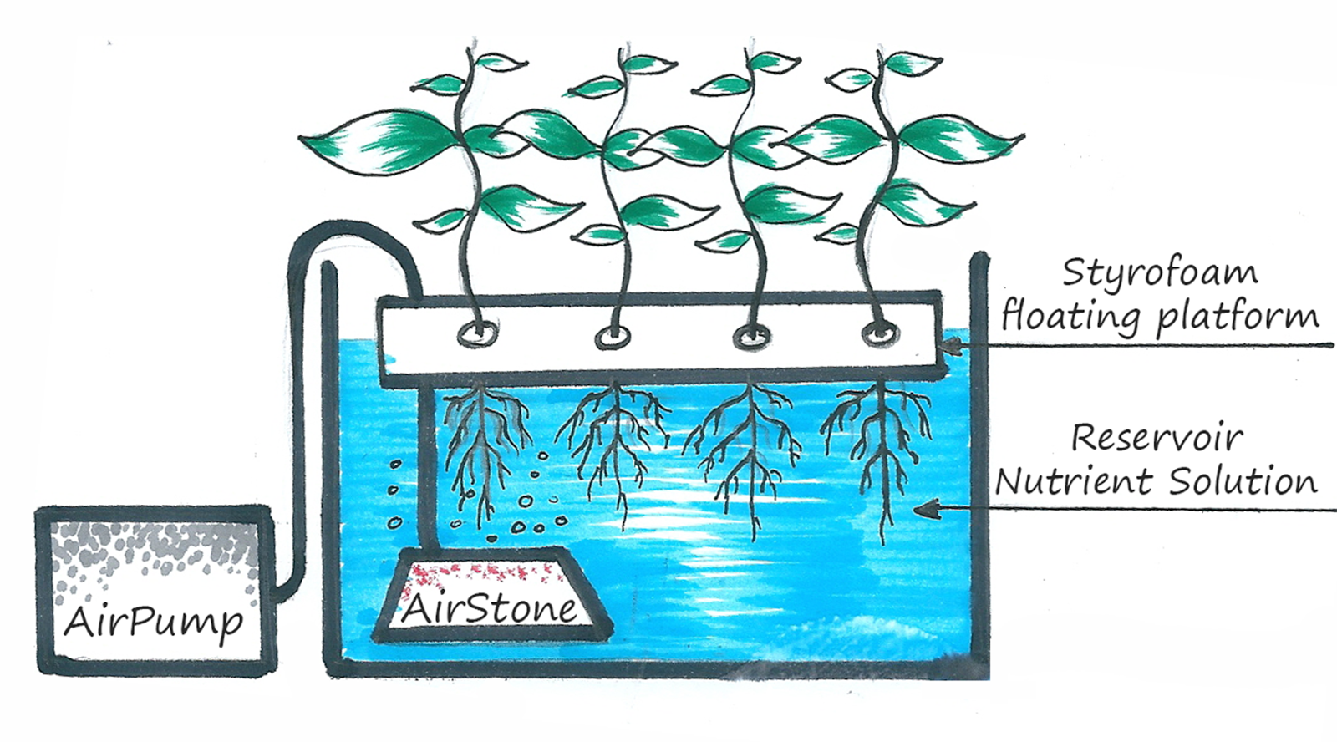

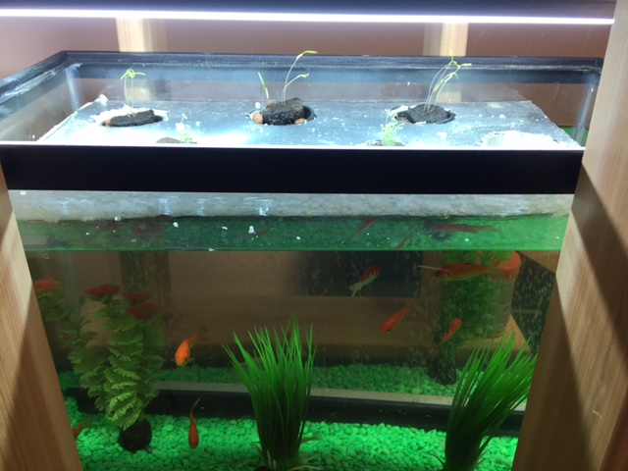

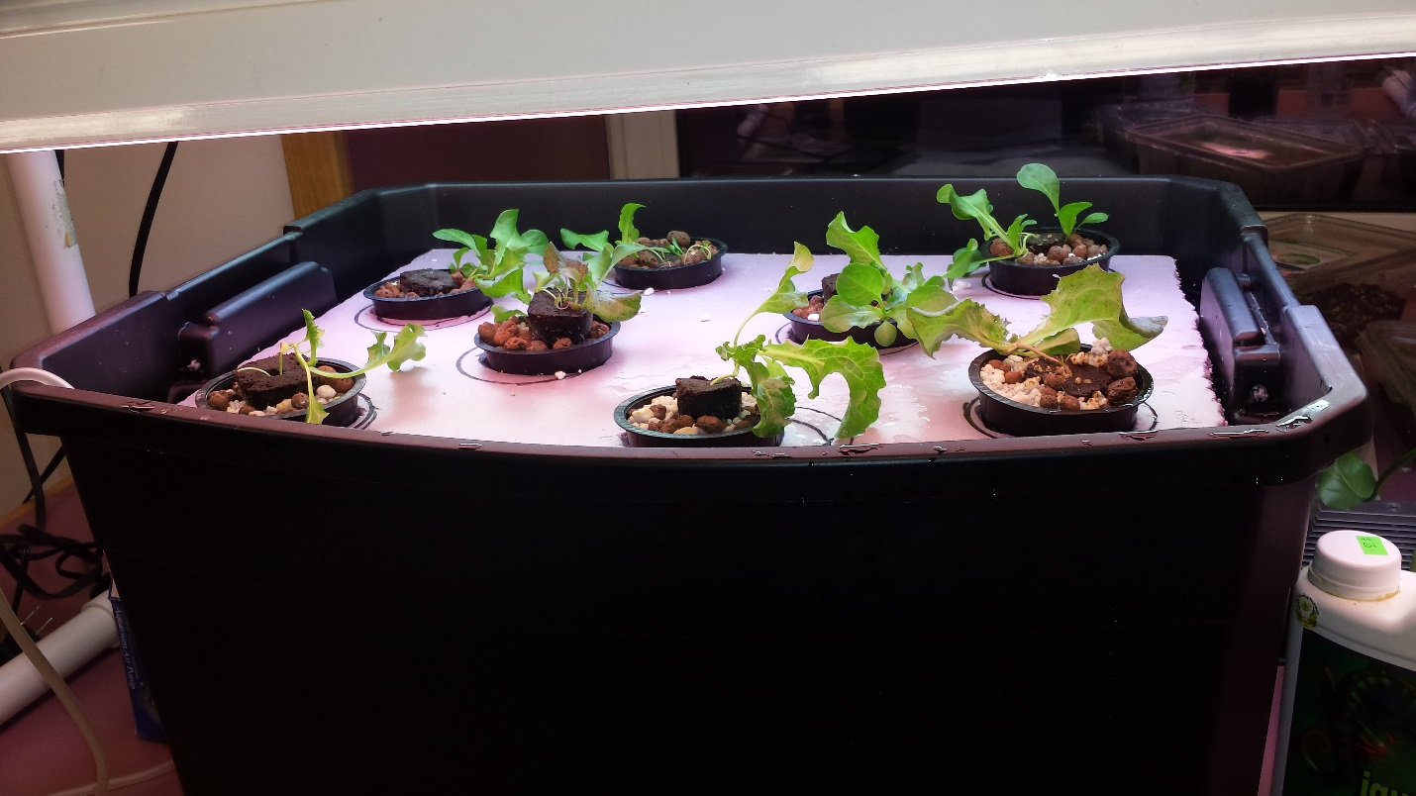
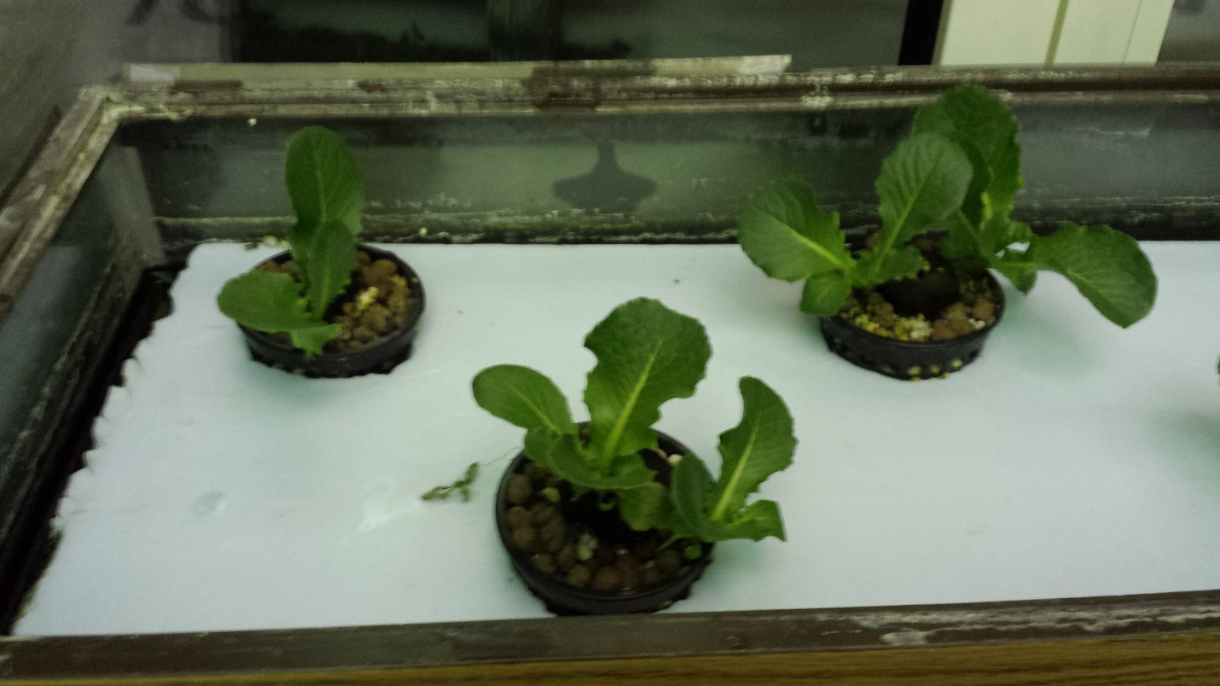
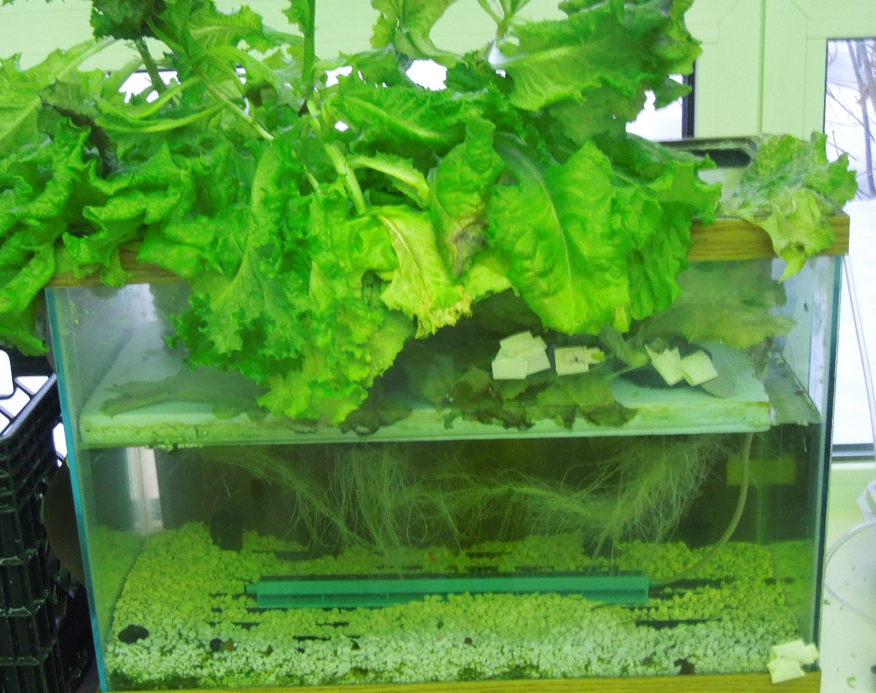
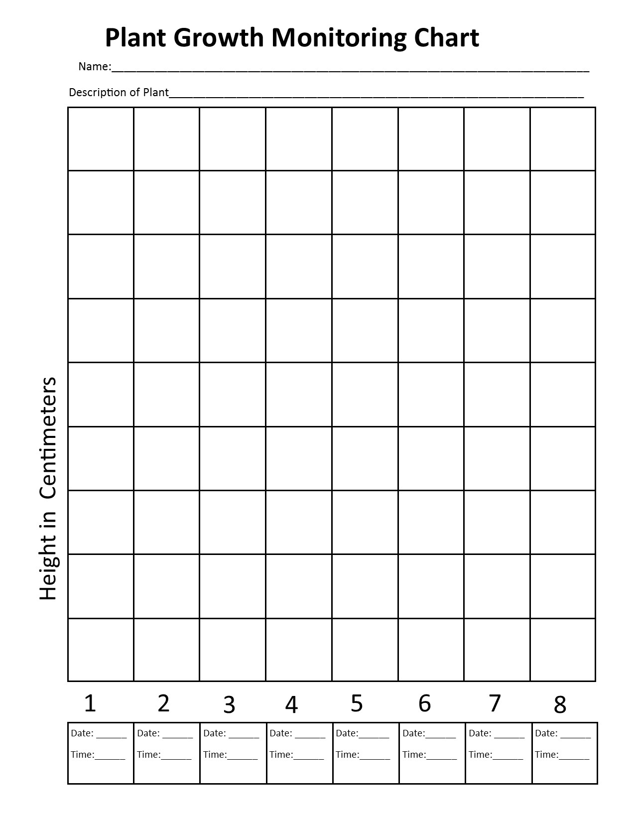
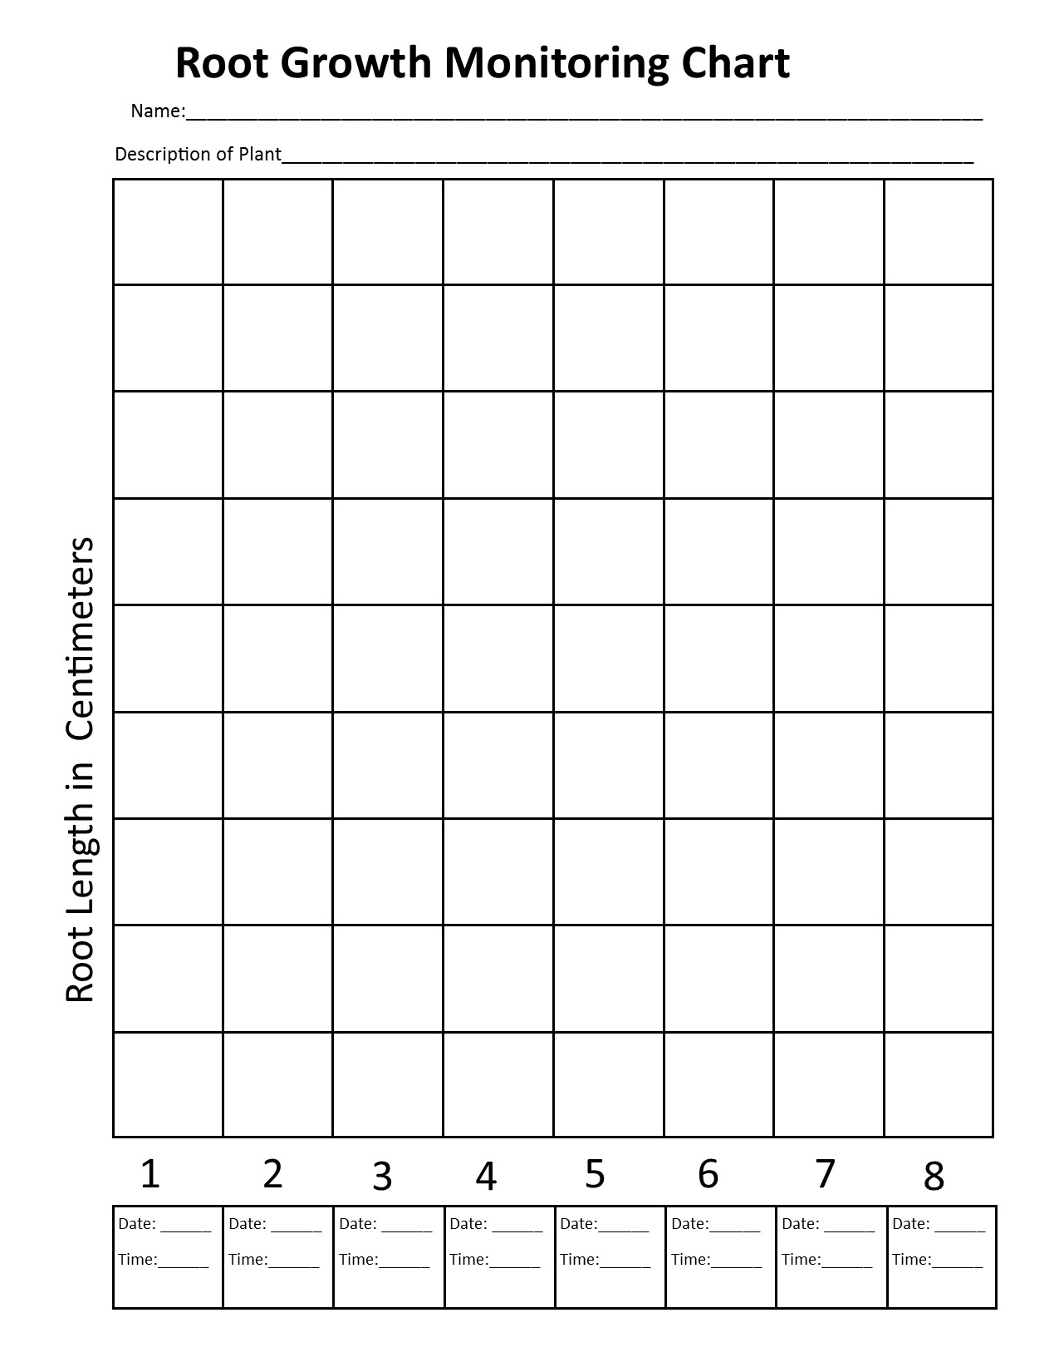
enes

